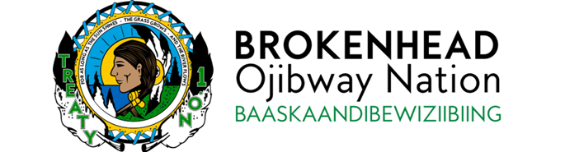
EMPLOYMENT OPPORTUNITY
Department/Unit:  Health | Position:  Health Director | Employment Type:  Full Time | Salary Range:  DOQ
JOB SUMMARY
Brokenhead Ojibway Nation (BON) is seeking a highly motivated, forward-thinking individual to join our organization as Health Director.
Reporting to the Chief Administrative Officer, the Health Director provides strategic and operational leadership for the planning, design, delivery, and evaluation of health programs and services that support overall community health, wellness, and healing.
This role requires a proactive leader with strong initiative, a positive leadership style, and the ability to work independently while collaborating closely with staff, community leadership, community members, and external partners. The Health Director ensures services are culturally relevant, culturally safe, and responsive to the evolving needs of the community.
KEY RESPONSIBILITIES
Leadership & Programs
- Provide overall leadership for BON’s health programs and services, ensuring alignment with community priorities, BON strategic direction, and funding requirements.
- Plan, design, deliver, and evaluate culturally relevant and culturally safe health programs that support prevention, wellness, healing, and continuity of care.
- Oversee workplans, budgets, reporting, performance measures, and continuous quality improvement processes.
Team Leadership
- Lead and support a multidisciplinary health team, providing clear direction, coaching, and performance management.
- Foster a respectful, collaborative, and positive team culture while working independently with initiative and accountability.
Community Support & Partnerships
- Support individuals and families during emergencies, trauma, and crisis situations, and provide leadership during critical incidents.
- Build and maintain effective relationships with leadership, community members, service providers, funders, and regional partners.
- Communicate health information clearly and advocate for BON’s health priorities.
Governance & Accountability
- Ensure compliance with legislation, funding agreements, privacy requirements, and BON policies.
- Prepare reports and recommendations for senior management and Chief and Council.
- Support audits, accreditation, and funding accountability requirements.
QUALIFICATIONS AND SKILLS REQUIRED:
- Post-secondary education in health administration, nursing, social work, or public health. A combination of education and experience will be considered.
- Minimum of 5 years of demonstrated leadership experience in health or social services, preferably within a First Nation or Indigenous community.
- Strong understanding of community-based, culturally grounded approaches to health and wellness.
- Proven ability to take initiative, manage priorities, and lead teams effectively.
- Excellent communication, relationship-building, and problem-solving skills.
- Proven ability in people management, including hiring, coaching, performance management, and team development.
- Experience working in First Nations communities and knowledge of Indigenous health priorities.
- Familiarity with federal and provincial health funding programs and reporting obligations.
- Excellent verbal and written communication skills, including public speaking and group facilitation.
- Ability to maintain confidentiality and exercise sound judgment.
- Ability to travel as required.
- Valid Class 5 Driver’s License and access to a reliable vehicle.
- Clear Criminal Record Check, Child Abuse Registry Check and Adult Abuse Registry Check
- Must be wiling to submit to a pre-employment and future random drug testing.
BON offers a competitive compensation package. Preference will be given to Indigenous people, applicants are encouraged to self-declare.
Application Deadline: May 15, 2026 at 4:30pm
Please submit resume, cover letter and three (3) references, including recent or current employer to:
Human Resources Department
Brokenhead Ojibway Nation
Box 180
Scanterbury, MB R0E 1W0
hr@brokenheadojibwaynation.com
Fax: (204) 766-2021

We thank all who apply and advise only those selected for further consideration will be contacted.

The Brokenhead Ojibway Nation is committed to equity in employment. Date posted: May 4, 2026

